**Gaming and Simulation Design Principles I**

CIT114

**Game Design Document**

*Yellow - 01*

**Design History**

***Updated prior each submission***

* + Version 1.0 – *October 1st.* Part 1*: Provided an introduction with our vision and a logline.*
  + Version 2.0 – *October 29th.* Part 2: *Changed Logline as well as add detailed information of the formal and dramatic elements*
  + Version 3.0 – *November 19th*. Part 3. *Clarification in the vision, added full list of characters, and filled in ambiguous portions of formal elements*
  + Version 4.0 – *December 1st*. Part 4. *Finished up the overworld explanation and provided a little bit of the media.*

Table of Contents

2 INTRODUCTION 4

2.1 Game Logline 4

2.2 Vision 4

3 FORMAL ELEMENTS 4

3.1.1 Players 4

3.1.2 Objectives 5

3.1.3 Procedures 5

3.1.4 Rules 5

3.1.5 Resources 5

3.1.6 Boundaries 5

3.1.7 Outcomes 5

4 DRAMATIC ELEMENTS 6

4.1 Game Characters 6

4.1.1 Player Characters (PC) 6

4.1.2 Non-Player Characters (NPC) 6

4.2 Story - *Optional* 8

4.2.1 Synopsis 8

4.2.2 Complete Story 8

5 GAMEPLAY DESCRIPTION 12

5.1.1 Controls 12

5.1.2 Interfaces 12

**Quit to Main Menu-** Upon selection will take the player back to the main menu screen 14

**Exit to Main Menu-** Selection takes player back to the main menu screen. 15

5.1.3 Levels 15

6 GAME WORLD 17

6.1 Overview 17

6.2 Key Locations 17

6.3 Physical Objects 18

7 MEDIA LIST 18

7.1 Environments 18

7.2 Characters 20

7.3 Music and Sound Effects 20

# INTRODUCTION

## Game Logline

A story-driven, puzzle-solving adventure game that takes place in the Underworld based off of Greek mythology.

## Vision

The most compelling thing about the game is discovering the story through completing puzzles and exploring the world. The game is trying to engage the player through the story and puzzles to convey a meaningful and thought-provoking theme where the player should be able to derive their own conclusion. Additionally, the player will become immersed through the complex message and uniquely themed puzzles to become attached to the main characters and the struggle they go through. Phoenix, the main character, has to go through the Elysian Fields, Tartarus, Elysium, the Fields of Asphodel, and through Hades’ Castle to unlock all of his memories. The person playing should consider their morals and enact them in the game. They should have feelings of empathy, indecisiveness, and sympathy for the characters in the story, as well as feel challenged and motivated to complete the puzzles and progress through the story to find a resolution. Also, they will take away a sense of completion and accomplishment from finishing the game. This game is unique not just through the story, but through in-depth puzzles that relate to the story. These puzzles are mandatory, must be solved to regain the main character’s memories, or are optional and provide extra content and information to help the player come to conclusions about the theme of the story. If the player did not travel around enough, there is plenty of content to allow for replay-ability. The setting is also in a different place than games from this genre and is viewed in top-down style. The player will have enough control over the game-world to solve the riddles the environment has in store for the person playing, allowing more than one method of solving the puzzle. The player will control how much of the story he or she will be exposed to based off of how much time is invested into the game and the different side-puzzles that are not integral to progressing through the main story. There are at least 10 - 15 puzzles that have to do with item usage, aligning certain objects in a particular way, drag-and-drop puzzles, interactions with non-playable characters, and player movement.

# FORMAL ELEMENTS

### Players

#### Target Audience

Our target demographic is adolescent males in English-speaking countries who like to explore and get achievements.

#### Player Interactions Patterns

Our game is a Single Player versus Game experience.

### Objectives

The objectives are as followed: escape, exploration, alignment, and solution. First, to escape, the player has to get the main character through specific places. Then, the player has to navigate through the levels through exploring all the possible areas. Next, alignment is portrayed by the player interacting with certain puzzles to manipulate objects in certain ways. Finally, the game is solution-based because the focus is primarily on the puzzles that progress the videogame further.

### Procedures

The player can put the game into action by moving either by walking or running. As the player interacts with other characters and objects by talking, moving, and other specific actions, they cause progression of the story. Special actions are available when the player initiates interaction with puzzles.

### Rules

The player’s primary actions are to move and interact. Some interactions require an item to progress. Each puzzle has their own rules which are established directly by the game before they start it. However, there are some intrinsic rules the player has to conclude themselves, such as that lava can kill you/harm you.

### Resources

There are next-to-no resources in the overall playable game. Specific items will be limited to the puzzle they appear in like a shovel or a light source.

### Boundaries

The player is only limited to the play-space. The character cannot leave the “playable-world” and the puzzle scenes are limited to the specific puzzle they appear within.

### Outcomes

There are several end states the player can experience. They collect bits of a missing story in order to find out what happens. Winning depends upon how much of the story they have gathered. If they have gathered all of pieces of the story, then they win.

# DRAMATIC ELEMENTS

## Game Characters

### Player Characters (PC)

#### Phoenix

* Description: Six foot man with long, slightly curly brown hair that trails down to his shoulders. His eyes are hazel, green with slight traces of brown in the middle, and narrow like he is always aggressive. He is slightly muscular and has an olive, light brown skin tone.
* Properties: Can interact with NPCs and objects, can run and walk, and can solve puzzles with the player's help.
* Behaviors: A rebellious, level-headed man with a caring personality. He is willing to go against the status quo in order to make sure that those he loves and even those who he doesn't know is well-taken care of and happy. Although he believes in justice, his opinion is that people shouldn't be submitted to the deeper, darker parts of hell for frivolous reasons.

### Non-Player Characters (NPC)

#### Cerano

* Description: Black Newfoundland dog with big chocolate-colored eyes.
* Properties: He guides the player through Elysium while he has to lay low. He gives little hints towards the optional puzzles in the area, but once he leaves Elysium, Phoenix loses his assistance.
* Behaviors: He is very much like his name, but also laid-back and lazy. He is more like a guide to the player than the other canines.

#### Berthold

* Description: Black Labrador dog with light blue eyes.
* Properties: He is willing to help the player with one of the main puzzles, helping dig in Tartarus. He appears much later with the other dogs.
* Behaviors: He is loyal, incredibly serious, and is more helpful than the other canines. He is very considerate of the main character, knowing that he doesn't belong in Tartarus, and is desperate to assist in order to make things right. He is also very regal.

#### Camus

* Description: Black pug with midnight black eyes.
* Properties: He instigates a chase through the meadows with the main character. While running, avoiding the innocent spirits, Camus chases, posing as a threat.
* Behaviors: He is impulsive and impatient, but provides comedic relief as he attempts to hinder the player. He is fierce, aggressive, but also a little bit foolish as he tries to eliminate the main character.

#### Spirits

* Description: Almost transparent beings of many sizes and shapes. They can either be the wanderers (people in Asphodel Meadows), the lost souls (people in Tartarus), or the righteous (people in Elysium).
* Properties: They walk around and talk with the main character when the player initiates conversation with them.
* Behaviors: Each have their own unique thing to say to either help the player with puzzles or something pertaining to the character's existence or progress.

#### Brandon

* Description: A man that's 5 feet 11 inches with short blonde hair and green and blue eyes.
* Properties: A man that's 5 feet 11 inches with short blonde hair and green and blue eyes.
* Behaviors: He used to be very nice and cooperative, but when messed with, he is full of revenge and scorn.

#### Lucia

* Description: A woman that's 5 feet 5 inches with long black hair and light brown eyes. Skye is sometimes with her.
* Properties: The player can only see her and cannot interact with her outside of a cutscene.
* Behaviors: She is a very supportive and passionate woman who cares deeply for her lover/husband and child.

#### Hades

* Description: A middle-aged man that is 6 feet 2 inches that has long, brown, curly hair and dark brown eyes. He is dressed as if he lives in ancient Greece.
* Properties: The player can interact with him at the end of the game, but only once.
* Behaviors: Very calm and adept at ruling the Underworld, he knows full well what should be done with Phoenix, but allows Phoenix the chance to explore and regain his memories. He is also very compromising and giving.

#### Skye

* Description: A little bundle who has black hair like her mother and blue-green eyes when they are open.
* Properties: The player can interact with him at the end of the game, but only once. The player can only see her with Lucia and cannot interact with her much even during a cutscene.
* Behaviors: She doesn’t really have much of an adult personality since she is an infant, but she is very easy-natured and calm.

#### Hooded Judges

* Description: All three men look the same with grey cloaks with hoods. One sends spirits to Tartarus, one sends spirits to Elysium, and the last sends spirits to the Fields of Asphodel depending on the color orb they are matched with.
* Properties: The player can interact with them once at the beginning of the game. They take part in one of the beginning puzzles.
* Behaviors: All three are stoic, serious, and smart. They know about Phoenix and have to listen to Hades orders pertaining what to do with him.

#### Sculptor

* Description: Old man with bushy white eyebrows that obscure his eyes with a matching white beard who wears a dirty brown toga-type garb and sandals.
* Properties: The player will interact with him if he or she chooses to aide the sculptor and will begin and end a side-puzzle.
* Behaviors: A cooky and energetic old man who is very enthusiastic about his work and completing his statue.

## Story - *Optional*

### Synopsis

Our main character, Phoenix, wakes up in a mysterious world. He quickly learns he lost all of his memories. He is able to retrieve them via a mysterious glowing orbs of light found throughout the world. His adventure in the world consists of discovering giant groups of people who performed slave labor, finding several talking dogs and meeting with Hades amongst other adventures. His memories consist of finding the love of his life, Lucia, only for his friend to rape her. Eventually, his house was burnt down trying to save his Lucia and their child, but he died which is what led to the beginning of the story in the first place. Phoenix makes it to Elysium where he was able to watch over his wife and child.

### Complete Story

The main character opens his eyes, awakening from felt like a long sleep. He finds himself staring up at a dark violet sky, littered with constellations. He realizes that he can’t remember anything, especially where he is located. He slowly gets up and checks himself for injuries. Finding none, he turns around and faces a vast river. Astonished, he marvels at the size and pale color of the water. He decides to stay away from the river, assuming that he almost drowned, and heads toward the opposite direction.

As he travels, he notices people faintly glowing a sky blue, all walking toward a specific direction together. He can either choose to follow the crowd or adventure another direction. If he chooses to go the other direction, he feels eyes watching his every move, but can’t determine where it is coming from. He comes across what looks like a cave entrance. If he walks inside, he is met with complete darkness. Suddenly, he stumbles to the ground as a memory flashes in his mind. He sees himself standing over a man with blonde hair, bloodied and unconscious. After he regains a memory, a ball of light materializes in front of him. He processes the memory, trying to find a conclusion for it before moving on. This initiates the first side puzzle. As he maneuvers through the cavern, he hears a neighing horse and is faced with a gigantic ebony stallion near the end where he can see the a glimpse of the beginning of a purple river. It freaks him out and he is chased out of the cave. He then decides to follow the glowing people to a massive shrine-like place where three hooded men sit listening to people.

As it becomes his turn to speak to them, they ask for his name. He struggles to answer. They notice his hesitation and then another puzzle takes place. After the puzzle is solved, another memory returns to him, this time being just a woman calling out his name, his vision coated in darkness. She sounds frantic to him and then he hears crying. His attention snaps back to the three men sitting in their seats. Phoenix gives his name to them and they glance at each other. One of them points to a few of the glowing people and tell him to follow them to “the mines”. He doesn’t want to argue and follows, but there is another optional path.

If he follows the optional path, he comes across a field with trees and sparkling floating lights, almost like fairies. He finds a few nymph-like creatures dancing, their bodies hardly covered with leaves and vines. As he steps forward, they notice him and disappear. Another memory brings him down to his knees. This time, he is with a woman with long black hair and big brown eyes. They banter playfully back and forth to one another in a home setting before she coaxes him to the bedroom. He then asks her if she still likes him even though he’s not a perfect man, even after knowing what he’s done. She says that he’s made up for it through hard work alone and they kiss passionately. Phoenix pants heavily, not sure who the woman was. He gets up and searches for more people, eventually following them until he reaches the Mines.

He trails behind them down what appears to be the side of a mountain until he notices that almost all of them have fell in around him into a red river below, finding himself alone. As he watches another person that came up from behind him fall, he feels himself being pushed into the chasm and he falls. When he wakes up, one of the people prod at him, insisting that he get back to work, thinking that he was asleep. He gets up, is handed a shovel, and then is left alone. As he goes around, mimicking and working like the others, he wonders why it’s like this since no one appears to be getting paid and talks to some of the other workers. As they tell him why they are working here, Phoenix gets confused and argues against why some of the people are there. He comes across Berthold and the two converses about the situation. Berthold feels as though Phoenix doesn’t belong here and leads him to a desolate place in the mines. He tells Phoenix to start digging, which starts a puzzle.

After the puzzle, Phoenix follows the path it provides him. On the way, he is hit with a memory, this time taking him back to when it was his first day at preschool. He goes up to a blonde and watches him, then decides to play beside him, eventually talking with him. Phoenix starts to ask Berthold why he keeps getting these memories, but Berthold is already gone. He continues upward until he is hit with a somewhat bright light. Suddenly, he finds himself in a beautiful plateau of trees filled with fruit and very happy people with a brighter, purple glow to them. As he makes his way through the area, the people gaze at him with either curiosity or disgust. Phoenix then feels that he doesn’t belong and wanders about until he is seemingly alone. There are two paths before him again. If he chooses the left path, he comes across another river, this time being pure black. Then, a puzzle is left before Phoenix and he regains another memory after solving it. This time it’s him in college, taking his roommate, Brandon’s, flash drive from his desk and puts it into his computer to get an assignment before deleting it and putting it back on his desk. Shocked by this, Phoenix tries to unearth what just transpired, but realizes that’s probably why he was sent to the mines. He turns back, not interested in swimming in water that is pitch black.

He goes down the right path, he comes across another dog, this time Cerano. They greet one another and Cerano tries to convince him to continue through, but only if he disguises himself. The catch, he has to remember something very defining about him. Another puzzle commences and he then remembers becoming the president of a very distinguished and important company. That gives him the ability to pass through the meadows and Cerano leads him through the quickest route, avoiding as many eyes as possible, which is another puzzle. After getting through the area to more fields, he blinks, Cerano disappearing in the short time he wasn’t looking. Next, another memory reappears in his mind, this time Brandon, the blonde from preschool all grown up, is standing next to him, both in tuxedos. He reassures Phoenix that all will be well and then the woman from before walks down the aisle towards him. A wedding takes place and the two are married fairly quickly. Phoenix opens his eyes, the happy memory making him cry happy tears. He felt horrible for even forgetting his wife, Lucia. Now, he was desperate to get out of this place and back to her. With a new motivation, he makes his way forward.

Suddenly, fog starts to envelop Phoenix as he makes his way through the fields. He comes across a few people, outlined with blue light and find them walking around mindlessly. He tries talking to them, but they won’t respond. As he continues, he has to navigate his way through so he doesn’t get lost. After the puzzle finishes, he gets lost anyway and panics a little. This time another memory arises and it is an unpleasant image of Brandon forcing himself on Lucia as Phoenix gets home from work. Phoenix goes to release his anger on Brandon, but Brandon escapes. Instead of chasing him, he goes to comfort Lucia, promising that he would never leave her. Snapping out of his memory, anger courses through his veins and he is even more desperate to get out since he doesn’t remember when that event took place. He ventures forward, determined to get out of this unknown place.

On the path slightly out of the way is another memory, this one a sparkling part on the ground that Phoenix must interact with. This memory contains Phoenix and Brandon arguing with each other. He tells Phoenix that he somehow got kicked out of college and he has to move out of the dorm and then Phoenix lets it slip out that it was his fault. Before Brandon could do anything, the memory ends. Even though he knows he’s done wrong, Phoenix still wants to get back to his wife as quickly as possible.

Finally, he reaches this dark, ancient Greek-like castle and tries to get inside, but can’t. Instantly, he is faced with another puzzle of somehow getting the door to open. When he gets inside, this time a curious memory reveals itself. He remembers being in the hospital, waiting outside of a room before being let inside after an incredibly long wait. He enters the patient’s room and is met with Lucia with a little bundle in her arms. The newborn looks very much like her mother and as Phoenix walks closer, the memory dies. With yet another reason to get back to his normal life, he progresses forward, navigating through the castle.

Then there is a puzzle pertaining to Phoenix going through certain doors. Some will send him back to the hallway if he’s not careful since he’s not allowed in there. He is only allowed in very few rooms. After he makes it to the last hallway, he regains another memory. This time, it’s him storming out of a court building. He roughly grabs Brandon’s shoulder and makes his ex-friend face him. They talk about the rape and Brandon makes a snide comment about how they both got away with stuff. As the memory fades, Phoenix releases Brandon and he finds himself back in the castle hallway again.

In one of the many rooms that he could skip, he has to pick the lock, once he gets the door open, he is met with another memory. He saw himself with Lucia and their daughter, Skye, in a doctor’s office. The doctor walks in with papers and hands them to Phoenix since Skye was being held by Lucia. The doctor explains to them that Phoenix is indeed the father because of checking through blood tests. Lucia and Phoenix breathe a sigh of relief as the memory comes to a close. Coming out of the memory, he sighs in real life, happy to know that there’s another person waiting for him outside of the place he’s in.

As he walks out the room and continues down the hallway, he comes across a black pug named Camus. After some threatening monologue from Camus, the canine initiates a chase. Not being all that intimidated to begin with, Phoenix doesn’t mind until Camus bursts through a door, breaking it into little pieces. A chase occurs and once Phoenix manages to outsmart Camus, the final memory is offered to him. This time it’s him running into a burning building, his home, rushing to save his wife and child. He can hear Brandon howling with laughter outside. He goes into the nursery and leads Lucia and Skye out, but before he could make it, he is hit in the shoulder with rubble from the burning house and falls. As everything becomes dark, Phoenix snaps back into reality as he finds himself in a throne room of sorts.

He meets with a man who looks very similar to himself, but exudes a dark yet calm aura. Phoenix shakes his head in disbelief as he comes to a realization that he’s dead. He asks who the other man is. He answers by explaining that Phoenix is in the Underworld and that he is speaking to the ruler, Hades. Hades apologizes to him and explains that Phoenix made the trip up until the point of the River of Lethe where he fell in and was swept away. His escort, Cerberus, had no idea where he ended up, so he split into three to check the zones of the Underworld to help get Phoenix back on track to meet Hades. Phoenix learns that he was meant to talk to Hades and when he asks why Hades reveals that Phoenix is a demigod and his son. Since they are related, he wants to offer something to Phoenix, but he can’t really bring him back to life. Along with giving Phoenix back all his memories, he offers that Skye will be given powers and a longer, more meaningful life by being watched over by all of the gods. Phoenix, although not pleased with this, learns to accept it and is left to go back to Elysium since he did die doing a heroic deed.

When he makes it back to Elysium, he finds a lake there. Without realizing it, he touches the water to wash his face off. He is awed when he notices an image of Lucia watching over Skye. As he tries to touch the image, there is a flash and he feels himself being transported. He’s outside of a rebuilt house. He makes his way to the door and knocks. Lucia answers the door with Skye asleep in her arms.

# GAMEPLAY DESCRIPTION

### Controls

**WASD keys** - Movement up, left, down, and right respectively.

**Spacebar** - Interaction with objects and people, also progresses conversations.

**Left shift button** - When utilized with the WASD keys, can allow Phoenix to run.

**Escape button** - Brings up the pause menu.

**Arrow keys** - Move up, down, left, and right in the pause menu and start screen.

**Enter button** - Picks a choice in the pause menu or on the start screen.

**Right mouse button** - Interacts with puzzles.

### Interfaces

**Starting Screen:**

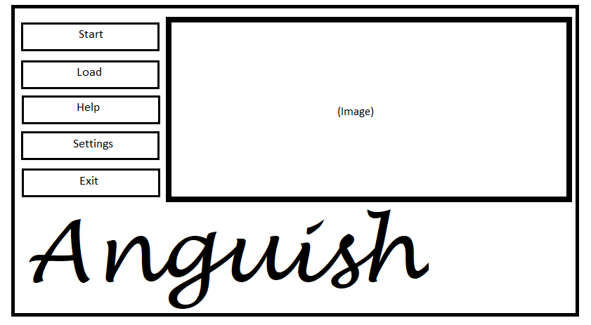

**Start** - Pressing enter on this selection will allow the player to play the game from the beginning.

**Load** - Pressing enter on this selection will allow the player to play the game from a saved point.

**Help** - Pressing enter on this selection will allow the player to view the controls of the game.

**Settings** - Pressing enter on this selection will allow the player to adjust sound settings and text speed.

**Exit** - Pressing enter on this selection will allow the player to exit the start screen.

**In game (no UI):**



There is no UI or the game space.

**Pause Menu:**

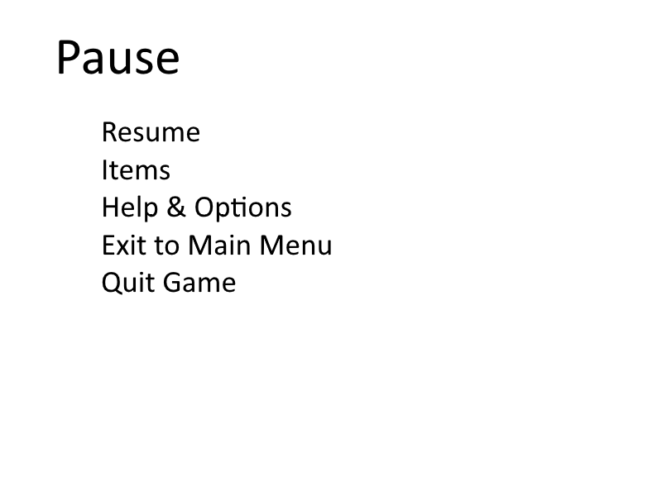

**Resume** - Unpauses the game.

**Items** - View items the player has picked up.

**Help & Options** - View game information on how to play and change some settings such as audio volume.

**Exit to Main Menu** - Leaves game and goes to the main menu shown above.

**Quit game** - Exits game to desktop .

**Death End Screen:**

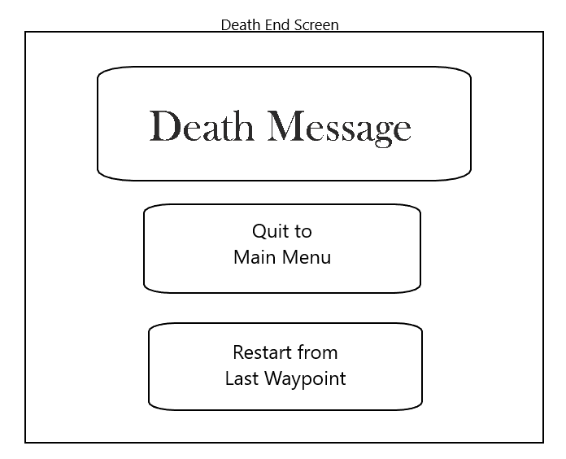

**Quit to Main Menu-** Upon selection will take the player back to the main menu screen

**Restart from Last Waypoint-** Upon selection takes player back to the last waypoint encountered within the game

**End of Game Screen**

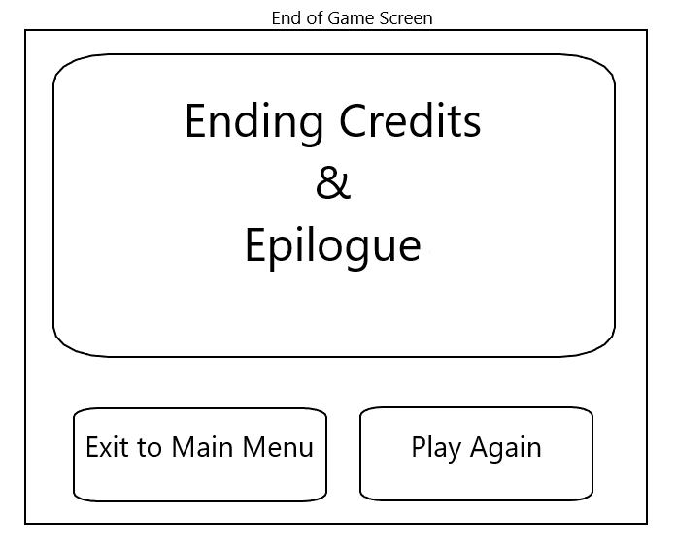

**Exit to Main Menu-** Selection takes player back to the main menu screen.

**Play Again-** Selection takes player back to the start of the game.

### Levels

There several puzzles the player will have to solve to get the full story.  We will use this section to try and explain all of them.  Note the player does not have to solve the puzzles in the order presented.  Some content might be cut or modified if the scope seems to be beyond our ability.

**Puzzle 1:** As Phoenix gains a light source, he has to travel through the cavern that he has found. There are many twists and turns inside that lead to dead ends. The right path is first going right, then left, then right two more times, then finally left again. There he should find the end of the tunnel, but he should not be able to access it. When he is being chased by the stallion, he has to run back the way he came in a time frame of two minutes.

**Puzzle 2:** There are three switches and four doors in a row. All doors need to be open in order to the player to progress. Each lever toggles the open/closed state of two assigned doors.  Lever 1 toggles doors 1 & 2, lever 2 toggles doors 2 & 3, and lever 3 toggles doors 3 & 4. By default doors 1 and 3 are closed while 2 and 4 are open.

**Puzzle 3:** There are nine tiles set up in a 3x3 plain. The player needs to align the tiles to make an image. They can only move tiles by selecting one and swapping its location with another adjacent tile.

**Puzzle 4:** Phoenix has to conjure up the light again, clicking different places on the screen as they present themselves. They disappear after a certain amount of time and clicking all of the orbs are necessary. The total number of orbs are 20.

**Puzzle 5:** Phoenix has to cross a chasm that appears to have no feasible way across except for an invisible walkway that Hades had made for his own use. Phoenix must use a light source to cast shadows on the path before him as a way to illuminate the path and make his way across.

**Puzzle 6:** Phoenix has to align different-colored orbs to the three hooded judges. He has to get clues from the surrounding people who come up behind him about how each judge presents themselves. when correct, the orbs will shine brighter, but the player will not know this unless they try it themselves. He has to align the purple orb with the middle judge, the green orb with the judge on the right, and the blue one with the judge on the left.

**Puzzle 7:** Similar to a previous puzzle, there are tiles on a 4x4 square where the player has to align the puzzles to make a certain image. They can only move tiles by selecting one and swapping its position with another adjacent tile.

**Puzzle 8:** There are several tiles on the ground -- each with different letters. The player has to travel across the tiles that match up pre-established words. The twist is that the words are in greek. Players would not tested on their ability to spell, but rather to memorize certain symbols.  The puzzle comes in three parts with three different words. The words are: ΖΩΗ (translates to “life”), θάνατος (translates to “death”), and αναγέννηση (translates to “rebirth”). If the player walks onto a tile that does walk on a matching letter, they will fall and lose.

**Puzzle 9:** Phoenix is attempting to escape from Tartarus, but can’t go back the way he came so he decides to use a shovel he was given to dig up through an area of soft ground he noticed earlier. However, he will come across several barriers to his path including bedrock which cannot be dug through and lava flows that should be avoided for obvious reasons. When he reaches the top he will have escaped to a new area.

**Puzzle 10:** Similar to puzzle 4, this time there are 40 orbs to click before they all disappear. This time, the orbs are focused around him to create a disguise for himself. This will allow him to look more regal for a short period of time in the city. If it runs out, he has to do the puzzle again.

**Puzzle 11:** Phoenix encounters a sculptor who has just finished creating a boulder for a statue that was damaged recently, but cannot move the boulder there himself and requests Phoenix’s aide. Phoenix must navigate through the complex maze that is Hades’ Castle to the statue where the sculptor can finish the statue.

**Puzzle 12:** In one of the hallways in Hades’ Castle, there is a bright light that flashes with a thundering sound following it. When this takes place, the player should not move Phoenix since he would be incinerated. When there are softer sounds, the player should maneuver Phoenix through the hallway.

# GAME WORLD

## Overview

The world that Phoenix adventures through is mainly a darker, more mysterious world unlike the real world, while the flashbacks will maintain more realistic, but slightly cloudy. The River Lethe is mainly a white river surrounded by rocks that Phoenix will have to climb up. Then he will proceed further away from the river, which has more grasslands with different-colored light orbs floating around, representing the spirits. Where the three judges are located is directly in the center of the Underworld. Southeast from the fields and river is the mines of Tartarus and the cliffside above it. In the northeastern portion of the Underworld exists Elysium. All areas have a darkened sky without stars except for Elysium. Elysium is meant to be a bright and beautiful place with many refined and heroic people. Next, Phoenix travels west to where the Fields of Asphodel are and it is supposed to represent a lost, misty place that is easy to get confused in. This represents the majority of the northwest. Hades’ Castle is at the most western point of the southwest area.

## Key Locations

**Next to River Lethe:** Since this is where the game begins, Phoenix will use the river as a starting point in his journey, avoiding it at all costs because he believes that he almost drowned.

**Elysian Fields:** This is a vast location of fields and meadows that Phoenix has to travel through to find the three hooded judges. The area is important because there are side areas that the player can have Phoenix explore. But if he follows the spirits, then it will directly lead him to the next area.

**Tartarus:** Secluded as soon as Phoenix reaches the chasms, this area is where Phoenix learns more about how others were condemned for things they have done in their lives. He works for awhile, then decides that he has to break out and get to the bottom of his missing memories. He meets up with Berthold and the trusty canine helps him get out and to the next location.

**Elysium:** This place is a beautiful and serene land where only the best of people were sent. Since Phoenix is not dressed the same way as the spirits are, he comes across Cerano and he advises him to disguise himself. After he is disguised, Phoenix can travel throughout the area without worry, choosing a few side areas to gain memories.

**Fields of Asphodel:** Another location that Phoenix has to adventure through. This area provides Phoenix with a key memory that helps him be able to get out since the area was trying to bog down his mind and keep him there.

**Hades’ Castle:** This is the final area that Phoenix has to traverse in order to meet Hades. He will then learn his lineage and how he got to the Underworld. This area has the most puzzles that the player will have to solve to get through. The area also contains the sculptor, Camus, and Hades inside.

## Physical Objects

**Shovel**: A shovel used to solve the aforementioned digging puzzle (See: Puzzle 9).  The player uses the shovel to dig through the puzzle, avoiding obstacles such as rocks and lava.  Without the shovel, the player cannot perform the puzzle.

**Light Orbs**: Orbs that redirect light for puzzles 4 and 10.  The player must click the orbs for light to appear. By clicking all of the orbs before they disappear, the player will solve the puzzle.

**Boulder**: A giant, spherical rock used in puzzle 11.  The player must move the boulder through a maze to solve its respective puzzle.

**Switches**: In puzzle 2 the player needs to flip the switches in a particular order to open a set of doors.

**Doors**: The obstacle blocking the player’s path in puzzle 2. They are opened by flipping switches in a particular order.

**Tiles:** Tiles of the floor are aligned in a 3x3 pattern in puzzle 3 (also appear in puzzle 7 in a 4x4 pattern). The player will arrange the tiles to form an image and will move them by selecting an initial tile as well as an adjacent tile to switch their places.

**Letter Tiles**: Tiles on the floor with different Greek letters on them.  The player can only walk on tiles that spell out certain words.  (See: puzzle 8)

# MEDIA LIST

## Environments

**Next to River Lethe:**

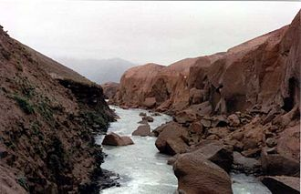

**Elysian Fields:**



**Tartarus:**

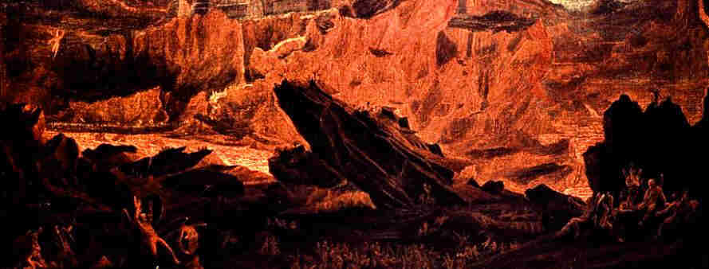

**Elysium:**



**Fields of Asphodel:**

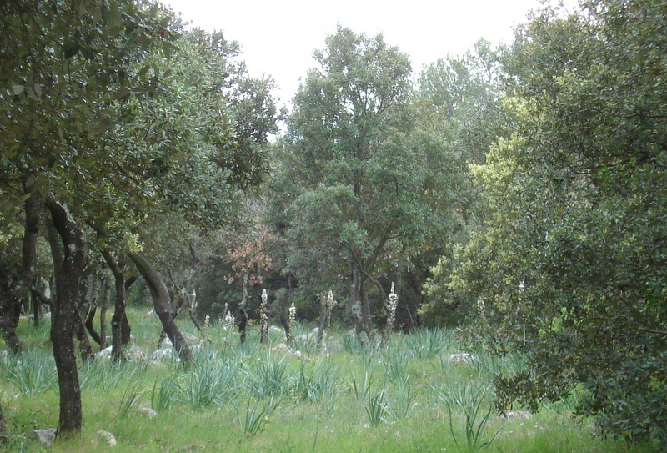

**Hades’ Castle:**

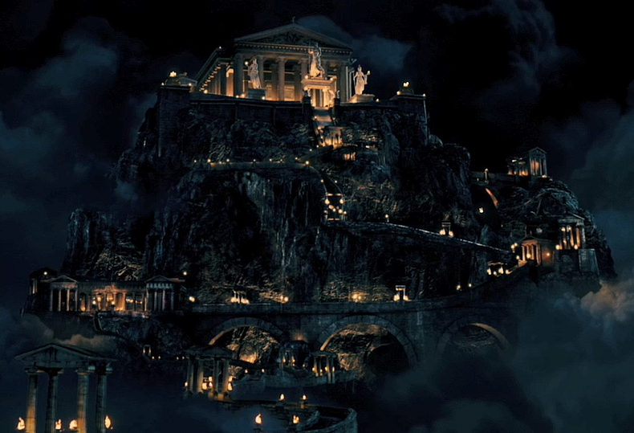

## Characters

Not Currently Applicable

## Music and Sound Effects

Not Currently Applicable